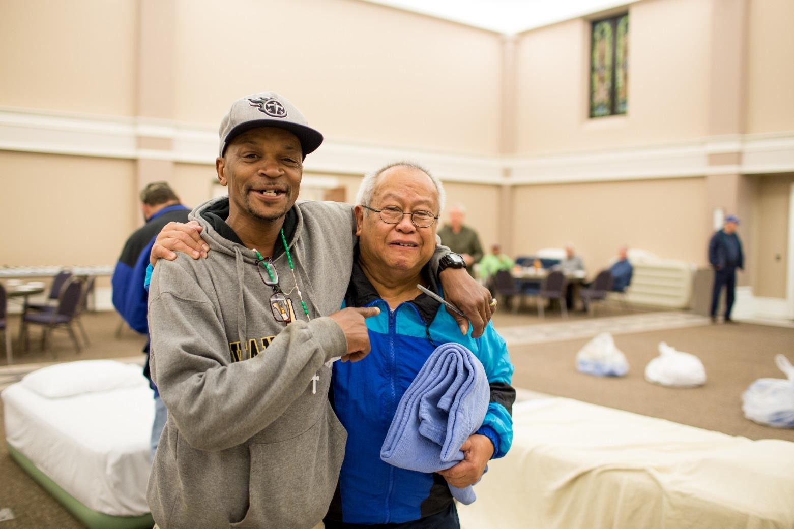



Winter Shelter Program
Congregational Handbook

It is in the shelter of others that the people live.
IRISH PROVERB

Room In The Inn Congregation Handbook
- The Room In The Inn Experience
- The Communion Meal
- The Room In The Inn Experience
- The Basics
- What is Room In The Inn?
- Mission
- Core Values
- History
- What is the Room In The Inn Winter Shelter Program
- What a typical night is like
- What does it take? How do we get started?
- Facilities
- People
- It Sounds Impossible
- Volunteers
- Recruiting Volunteers
- Healthy Boundaries
- Helping Individual Guests
- Getting Kids and Youth Groups Involved
- Involving Seniors
- The Role of the Coordinator
- Driving Instructions
- Your Guests
- Expectations
- Special Populations
- Men
- Older Adults
- Who are the Homeless?
- Hospitality
- Thinking about Hospitality
- Best Practices from Coordinators
- The Art of Being Present
- Holidays
- Practical Matters
- Insurance
- Cots/Mattresses
- Transportation
- Frequently Asked Questions



The Room In The Inn Experience

The Communion Meal

by Charles Strobel, Founding Director

Over the years, we have used many images to explain the importance of Room In The Inn. We’ve
described the program as a “sanctuary” from the violence of the streets, “Ellis Island” for urban refugees, a “Red Cross tent” in a war zone, an “oasis” in an asphalt desert, a gathering of “friends,” and as a rewriting of the original “no room in the inn” story.

After more than 30 years, the most important image we use now is the notion of a “communion meal.”

Consider all the ways we eat a meal—often on the run. Twelve people sitting individually at a McDonald’s eat a meal. But something is missing.

The gathering of twelve people in a Room In The Inn congregation also experience a meal, to be sure, but more. It’s not just a meal, but a communion meal. A communion meal is a meal that has sharing and intimacy. It reaches the depths of the soul and the heights of mystery. It is called sacred by people of religion. Unlike God, however, no one ever doubts or needs to prove its existence. A communion meal is experienced the way we experience the sunsets and the mountain tops.

Since 1986, homeless and housed individuals have gathered to sit down and share such a meal. It has been a powerful element of grace and hospitality that has transformed thousands of lives. Regardless of the food—chili, lasagna, turkey, hamburger, potatoes, corn, salad, rolls and drink—a Room In The Inn supper carries the force of the unleavened bread, unblemished lamb, and choicest wine eaten at those ancient Passover suppers and at the Last Supper.

Ultimately, such a meal contains the possibility of a communion with the God among us.

For more than thirty years people have come together to do this. Reluctantly at first, for suspicions were plenty. Some congregation members stood on the other side of a serving counter, like vending machines dispensing food without sharing, while homeless guests wanted to go off and eat in a corner by themselves.

But the invitation of God to come, sit down, and eat together won the hearts of all. And the miracle of a communion meal was born.

Now all these years later, I believe it remains our most important connection. Room In The Inn may be safe and warm, clean and quiet, dependable and secure. But most importantly, it is loving hospitality—found in the sharing, the laughter, the tears, the memories, the hopes and all those other moments that bring us communion with others and with God.

The Room In The Inn Experience

Charles Strobel, Founding Director
Room In The Inn is a simple concept addressing a complex problem. It starts with building relationships of trust and respect in an atmosphere of non-violence. It believes in the power of love offered in one-to-one encounters with one another.

What it is not

- Room In The Inn is not an attempt to resolve all of the issues of the homeless. The problems are too deep and too personal.
- Room In The Inn is not a program through which a congregation takes one or more homeless people “underwing,” providing them with economic assistance, job training, and personal spiritual direction. These gifts can be offered in time, as relationships develop.
- Room In The Inn is not about establishing another large shelter downtown where hundreds of people are cared for nightly.
- And it is not about boards of directors and major fundraising campaigns for capital projects.

What is it?

- Room In The Inn is a way for more people in every sector to understand the problems of the homeless by becoming directly involved with people who are homeless.
- Room In The Inn is a means through which congregations of every faith open their facilities to welcome twelve to fifteen homeless people as guests on cold winter nights.
- Room In The Inn is about changing people, guests and hosts alike. It creates an environment with the opportunity for the guests to learn that there are people who care…and for the hosts to come to

- understand that the faceless figure on the street corner is more than a statistic…and that there are solutions.
- Room In The Inn is about serving without prejudice or pride. It is about accepting everyone.
- Room In The Inn is about people of religion putting the tenets of their faith into practice.
- Room In The Inn is not about giving; it is about receiving. It is about everyone, both guests and hosts, receiving a blessing—an encounter with God in the midst of suffering, hardship, pain and grief.
- Room In The Inn is an opportunity, not an answer. It is an experience, not a solution. In short, Room In The Inn is an opportunity to experience the presence of God in a different way.

Finally, Room In The Inn gets its name from a story in the Bible about a family
coming to a small town called Bethlehem and not finding any room in the inn. We cannot go back in history 2000 years and change that story. But what we can do in Lexington, KY each evening we are open is to
change that story’s ending by providing room in the inn.

The Basics

What is Room In The Inn?

Mission

To provide hospitality that inspires individual growth and recovery in a peaceful environment that is free of drugs, violence, and abuse, through the power of spirituality and love.

Core Values
Through the power of spirituality and the practice of love, we provide hospitality with a respect that offers
hope in a community of non-violence.

History
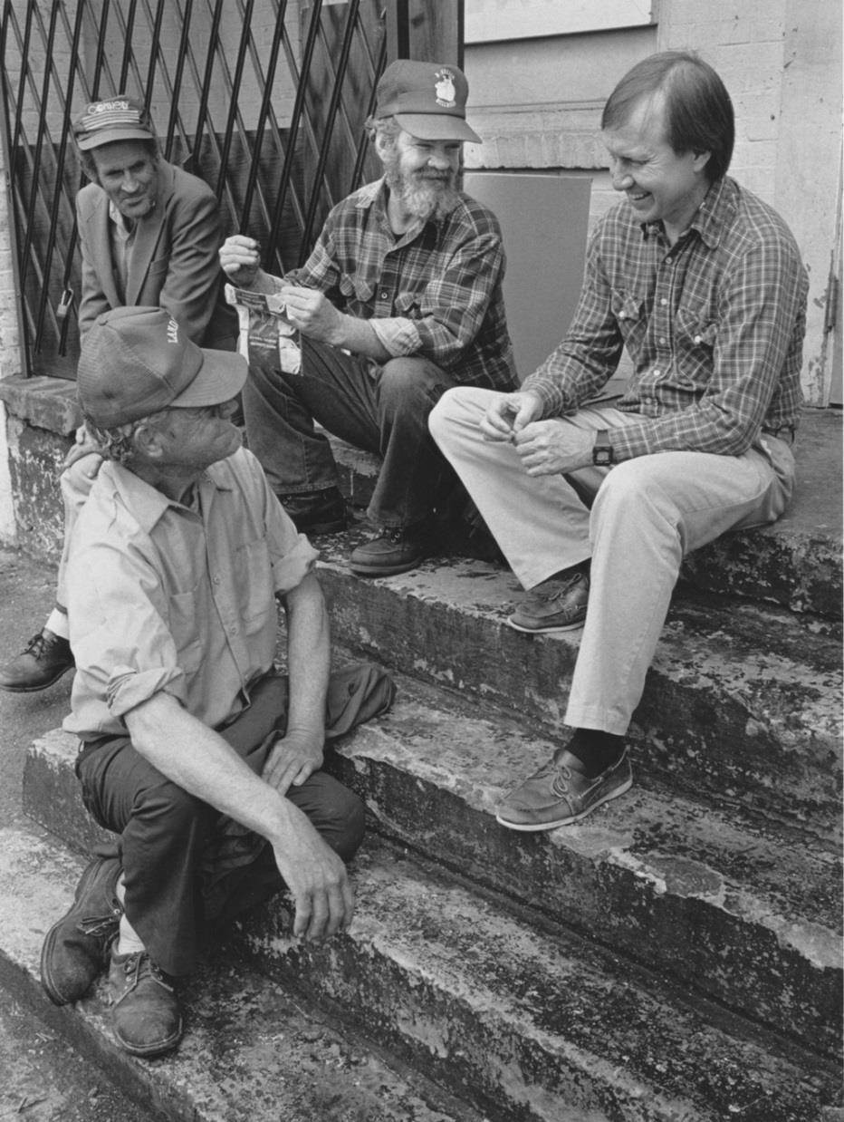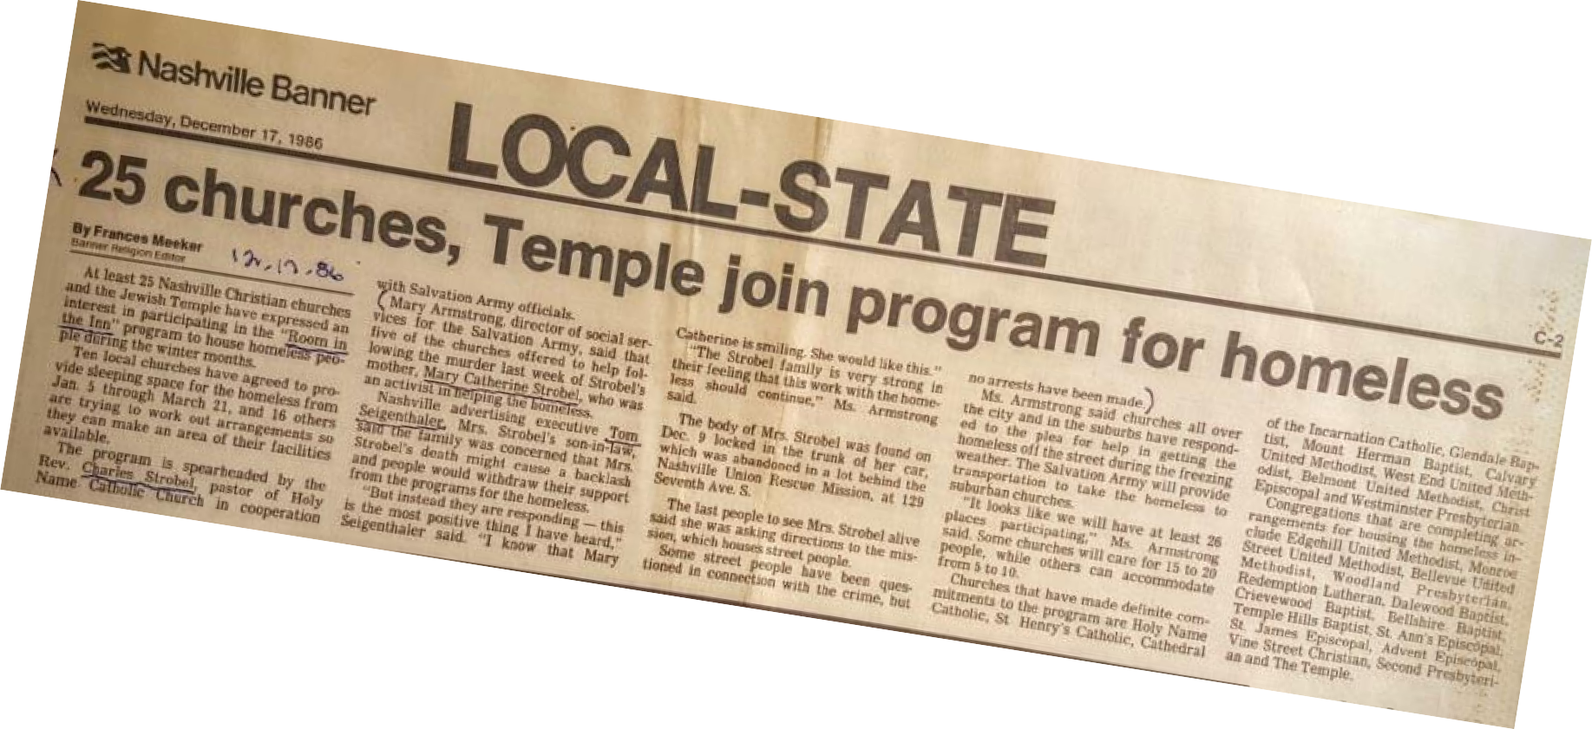ROOM IN THE INN-LEXINGTON is a seasonal winter ministry for homeless men of the greater Lexington area. Our heart and soul are the area congregations who, on a rotating basis, offer the grace of hospitality by welcoming small groups of homeless men into their doors every night of the winter season from November until March annually. Our ministry began in the Winter 2003 with only 4 churches hosting 12-14 homeless men 4 nights each week. We now have 26 congregations providing hospitality and shelter to approximately 24 Guests nightly. Our sole mission is to be the heart, the hands, and the face of Jesus Christ to those we serve by offering unconditional love and fellowship to those who are otherwise ostracized by society.

What is the Room In The Inn Winter Shelter Program?

Room In The Inn has been a community of people bound together to offer shelter and compassion to people experiencing homelessness. Local congregations open their doors to welcome guests in the winter months.

Room In The Inn’s winter shelter program runs November - March every year. Congregations host groups once a week, once a month, or just during the coldest months of January and February when the temperatures are dangerously low.

- Congregations are asked to host 12 male guests.
- Room In The Inn Board of Directors will guide you in setting up your program and will help train your team leaders and volunteers.

Volunteers serve in the following ways:

- Recruit volunteers from within your congregation or partner with other congregations/organizations.
- Transport guests, picking up each evening from Room In The Inn’s downtown location and dropping them off the following morning.
- Prepare and serve meals, including dinner, breakfast, and sack lunch for the following day.
- Assist with set up and clean up.
- Spend time during and after dinner each evening conversing with the guests, playing games, or watching movies.
- Serve as overnight hosts.

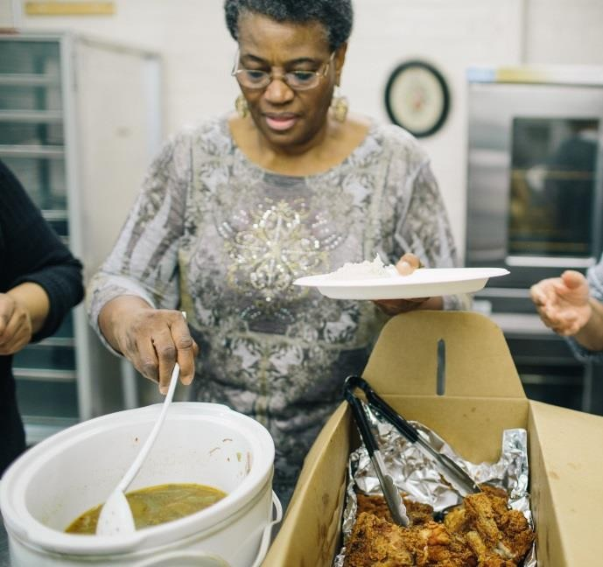
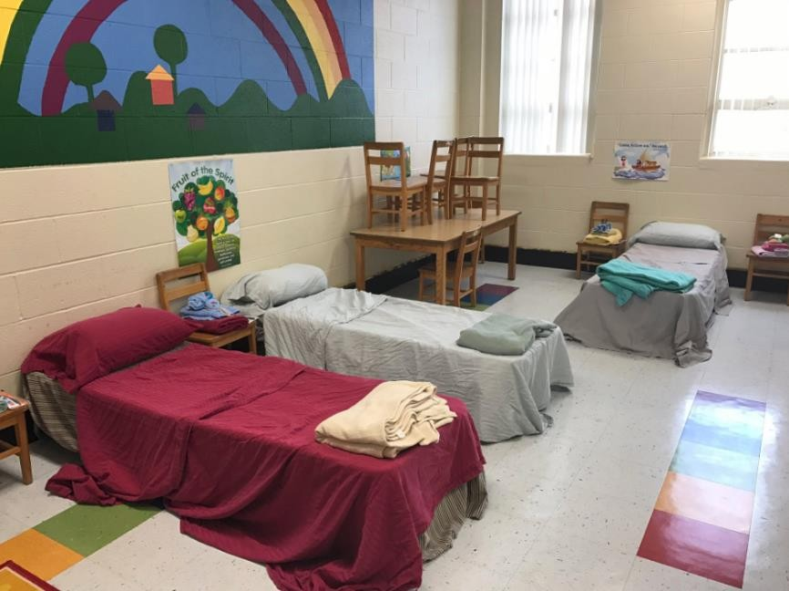

What a typical night might look like

Sample Schedule
6:00 p.m. Volunteers begin set-up at your church
6:15 p.m. First church picks up guest at Room In The Inn Downtown

6:30 p.m. Second Church picks up guests
6:45 p.m. Arrive at congregation
7:00 p.m. Welcome guests, allow them to get settled, explain smoking area, locations of bathrooms and smoking areas, lights out time, etc.

7:00-8 p.m. Dinner and conversation

8:00-10 p.m. Movie, television, or game time for those wanting to stay up 10:00p.m. Lights out
5:30-6 a.m. Wake up

6:00 a.m. Get ready for the day and clean-up sleeping area 5:30-6 a.m. Breakfast
6:00 a.m. Leave for downtown Campus, Volunteers complete clean-up

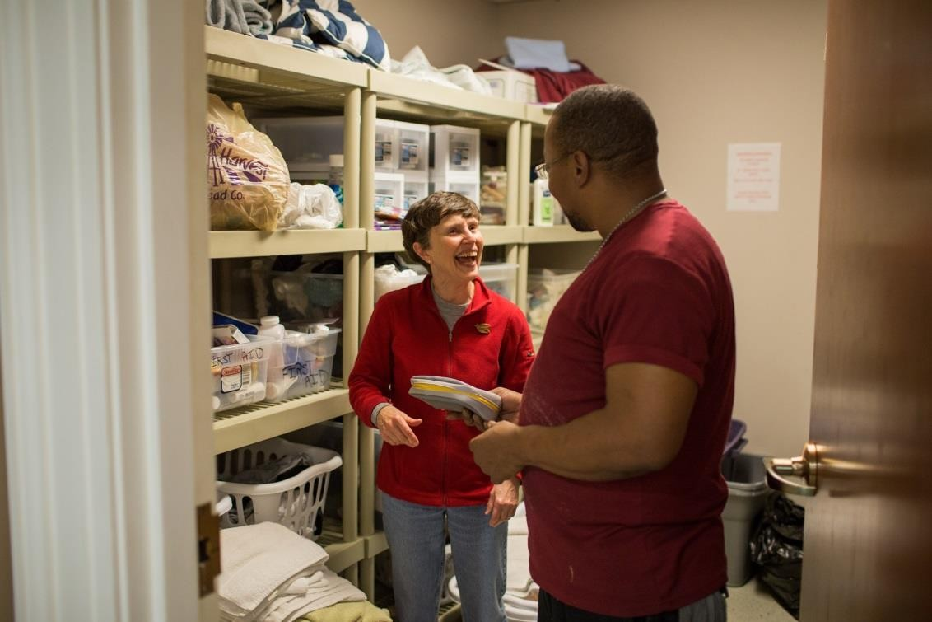

What does it take? How do we get started?

Congregations that host Room In The Inn guests are asked to provide just a few basics. Using the facilities and people they already have, congregations offer life-saving relief to those who would otherwise face winter on the streets. Lexington’s Room In The Inn Winter Shelter program runs November through March.

Facilities – Classroom space or community room, activity center

- Sufficient mattresses, pillows, cots, and blankets
- Table and chairs for sharing meals
- A place to prepare and serve food
- Enough food and drink for dinner and breakfast
- Adequate bathroom facilities
- Toiletry items like towels, soap, wash cloths, etc.
- Sufficient heating and cooling
- Approved safety exits with clear access
- Designated smoking area
- Basics like a first aid kit, fire extinguisher, and phone service

People – Staff and volunteers willing to give their time and energy a few nights during the winter season

- Transport guests from Room In The Inn’s downtown Campus and back in the morning
- Set up for Room In The Inn
- Prepare and serve the evening and morning meals
- Spend the night
- Clean up after Room In The Inn
- Schedule volunteers and providing oversight of the program
- Launder any linens and towels used

It Sounds Impossible…

You’re right---at first glance, sheltering people in a place of worship does appear to be a major problem. But it is not as complicated as it seems. Otherwise, there would not be so many Lexington congregations doing it year after year. The experience of 20+ congregations large and small is proof in itself that Room In The Inn is a reasonable, practical, and effective way to organize an emergency shelter.

The feedback from those congregations is overwhelmingly positive. Often, they are surprised at how simple and easy running a shelter can be.

There are many details of hospitality to attend to, but they are details that most people have faced in welcoming guests into their own homes.

Generally, what works at home for our friends will work at church for the homeless. You might find this hard to believe at first, perhaps because it sounds so simple. Yet it is true. A shelter at a congregation can be modeled after a home. What we like to provide our guests there---a clean, warm room, a fresh set of linens, a place to wash and bathe, some refreshing and nourishing food, and most important, personal conversation---we can provide at our own synagogue.

It takes simple knowledge and the will to do it.

(from the book Room In The Inn: How Your Congregation Can Help Homeless People by Charles Strobel)

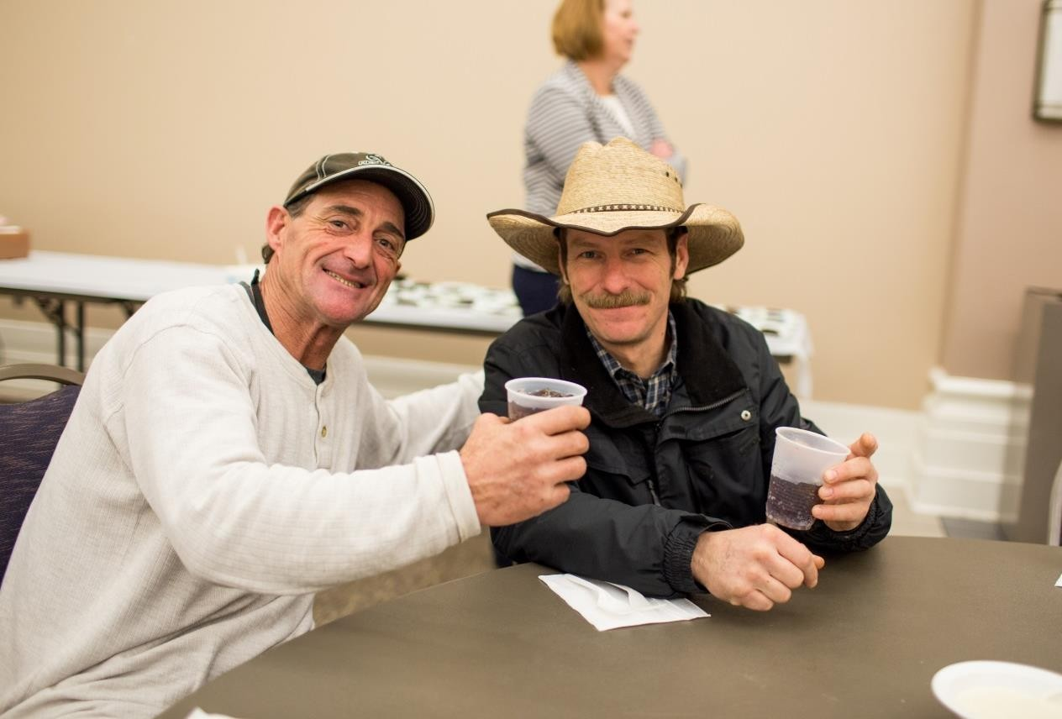



Volunteers

Recruiting Volunteers
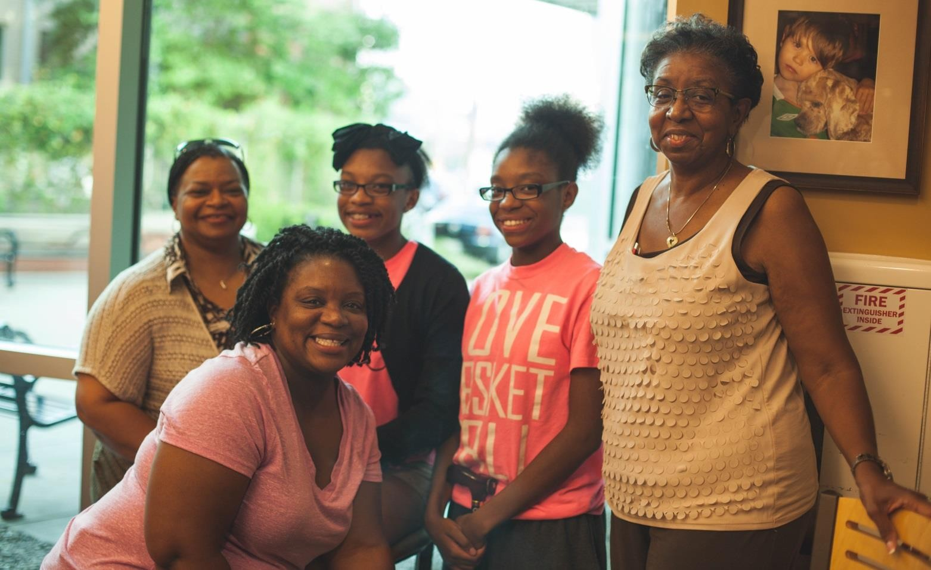
Volunteers are the heart and soul of Room In The Inn’s Winter Shelter program. Here are some tips for recruiting more people into this life-changing experience.

    - The best way to recruit volunteers is to ask people face-to-face. People are 41% more likely to volunteer if asked personally.
    - Be clear about what you want people to do.
    - Clearly explain the time commitment.
    - Provide detailed descriptions about the various responsibilities.
    - Offer volunteer positions at all age levels and all comfort levels.
    - Be sure to follow up with anyone who expresses an interest.
    - Recruit for specific positions rather than general help.
    - Make volunteering seem like a meaningful way to use limited free time.
    - Ask other volunteers to help you recruit.
    - Explain how volunteering makes a difference.
    - Encourage friends, life groups, and large families to host a night.
    - Ask people you wouldn’t normally ask.
    - Plan an event, meal, or informational meeting to attract volunteers.
    - Think of creative ways of presenting your needs.
    - Use positive language and methods for recruiting volunteers.
    - Reach out to new members of your congregation.
    - Share your passion.
    - Ask Sunday School classes and other established groups to volunteer together.
    - Have your clergy promote Room In The Inn during services.
    - Gather and share stories from volunteers about what Room In The Inn has meant to them.

Healthy Boundaries

- Working with individuals struggling with homelessness is a unique experience. Accordingly, it is important that unique considerations be made by all participating volunteers. Here are some best practices.
- Be respectful to all guests and volunteers and consider each guest as an individual.
- Do not share personal information such as your telephone number, address, or email.
- Do not friend guests on social media.
- Do not give guests rides in your personal vehicle.
- Maintain confidentiality. Do not share information about your guests with other people.
- Refrain from accepting gifts and giving gifts to individual guests. If you wish to do something special for an individual guest, please speak to a Room In The Inn staff member.
- Listen to each guest but do not expect to “fix” their situation.
- Be honest and do not make promises that can’t be kept. Feel free to say “I don’t know” or “I can’t.”
- Always use a calm voice and do not touch a guest without permission under any circumstance.
- Accept responsibility for your actions.
- Use your instincts. If you are uncomfortable with a guest or a situation, let someone know.
- Dress appropriately.

Helping Individual Guests

Room In The Inn guests often share their personal stories with volunteers at each congregation, and their experiences can inspire generosity and kindle a desire to become more deeply involved with a particular individual. This might include offering special assistance with employment, housing, medical needs, or some other request.

Before providing help to a guest, volunteers should consider consulting with a member of the Room In The Inn team. Staff members may not know about the difficulties a guest is experiencing and can provide additional support and guidance. They can serve as liaisons between the congregation and guest to protect confidentiality and fairness.

Finally, Room In The Inn staff members might be able to present a more complete picture of someone’s specific needs. Reaching out is an act of faith. Room In The Inn provides a venue for fellowship that can result in empowerment and change. Its staff serves as a sounding board in determining appropriate
assistance for individual guests so that a congregation’s resources can be used in the most effective way.

Getting Kids and Youth Groups Involved
All members of your congregation have something they can give your guests. Here are some ideas for involving youth.

    - Allow families volunteer together to serve a meal.
    - Give the youth group the responsibility of setting up the beds before the guests arrive.
    - Have the children decorate the bags for the sack lunches.
    - Invite the youth choir to perform for the guests.
    - Ask the teens to plan a holiday or football party.
    - Let older youth plan and prepare the evening meal.
    - Have children make placemats or cards for each guest.
    - Give each child five dollars and take a field trip to a dollar store. After a brief discussion about homelessness, allow everyone to purchase items guests would need.
    - Let the youth wrap holiday gifts or put together gift bags.

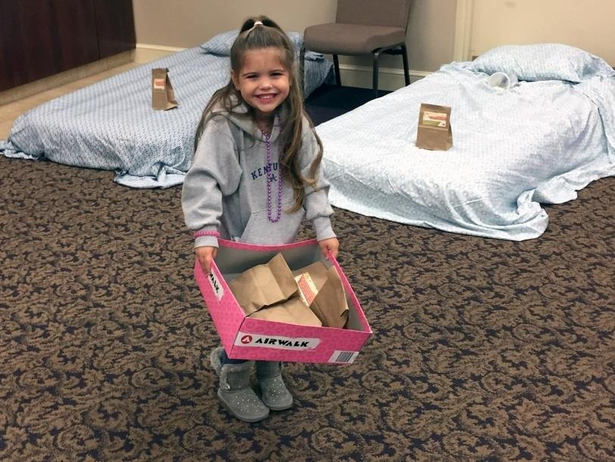

Involving Seniors
    - Call volunteers to remind them of their scheduled night.
    - Write thank-you notes to volunteers.
    - Send desserts or treats to serve with dinner.
    - Donate magazines for guests to read.
    - Knit or crochet hats and scarves for guests.
    - Write notes of encouragement for the guests.
    - Shop for items for sack lunches.
    - Donate supplies to the program.
    - Buy socks or underwear to distribute to the guests.

The Role of the Coordinator

Each congregation that takes part in Room In The Inn will have a coordinator. This person will assume the responsibility of overseeing the winter shelter program for the faith community.

There are five basic responsibilities for a coordinator.

Organization and Coordination

The coordinator will work with other volunteers to create a detailed plan for carrying out Room In The Inn. This will include identifying shelter space, obtaining cots/mattresses, soliciting donations for supplies, identifying volunteer tasks, and managing any budget.

Recruiting and Supporting Volunteers

There are many strategies for finding volunteers: announcements at services, notices in the bulletin and congregational emails, recruiting small groups and classes, posting on social media, participating in a mission’s fair, or hosting a Room In The Inn kick-off event.

To equip congregation’s volunteers for providing shelter, The Room In The Inn Board of Directors are available to lead training sessions. Please email ritilex@gmail.com to learn more.

Coordinators will want to teach volunteers the details of shelter at their individual congregations.

Scheduling

The coordinator is usually responsible for scheduling volunteers for each night of shelter. This would involve making sure all responsibilities are covered: set up, transportation, meals, overnight innkeepers, and clean up.

Serving as Liaison

Part of the coordinator’s role is to communicate on a regular basis with congregational leadership, the volunteers, and the Room In The Inn Board of Directors.

Handling Issues and Emergencies

There may be times when a coordinator must figure out how to cover for volunteers who don’t show up, resolve conflicts, and handle emergencies with the guests.

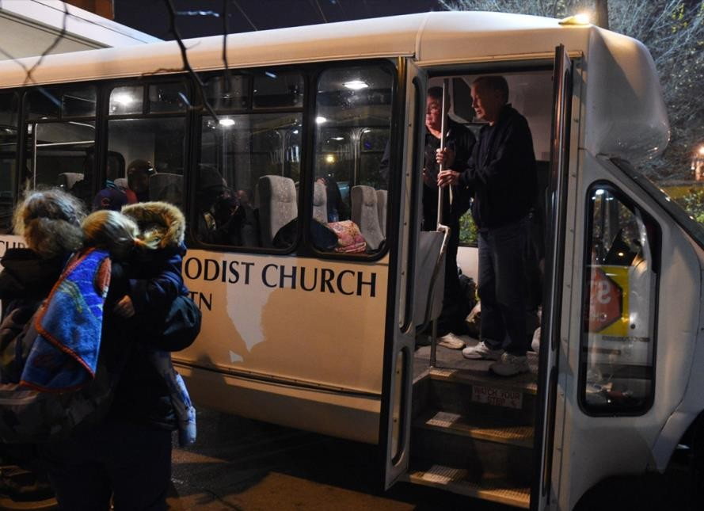
Driving Instructions
Please arrive between 6:15 and 6:30 p.m. to pick up your guests.

Please park your vehicle behind the house
as far as you can so other vehicles can
pull in behind you.

Please be sure to come inside to pick up the
Guests. You will also be given an attendance
sheet.

Room In The Inn Downtown
323 S. Upper Street
Lexington, KY 40508

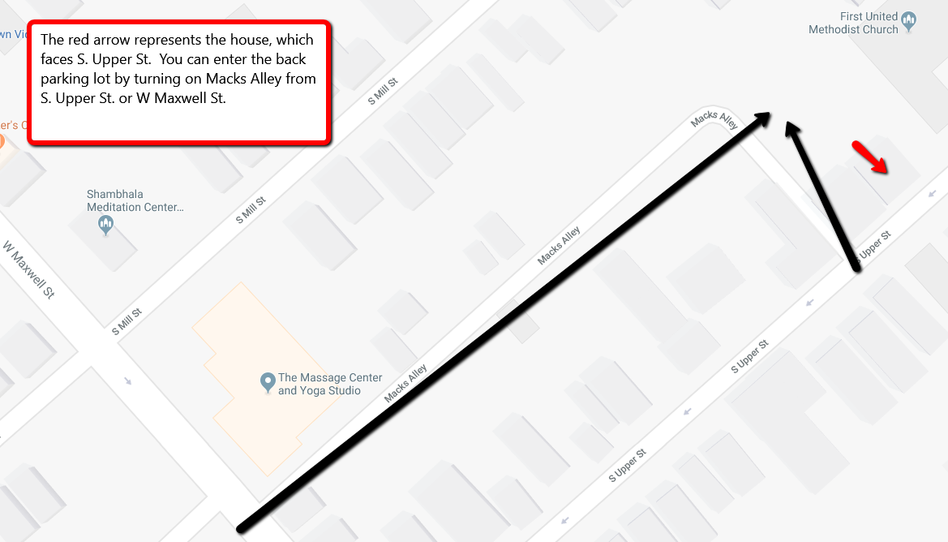

Your Guests

Expectations

All guests at Room In The Inn must attend an orientation session before staying at a congregation. This orientation explains how the winter shelter program works and the principles of nonviolence and respect. If guests do not follow these guidelines, they will be asked to leave the program for a period.

They will all be asked to sign the Room In The Inn Guest Contract.

Before guests leave Room In The Inn downtown, they must pass several checkpoints. Volunteers check guests for intoxication and behavioral issues. If a guest is not appropriate to stay at a congregation, other arrangements will be made for shelter.

If you have concerns about a guest’s behavior, please call one of the following:

Steve Clark Dispatch Coordinator at 859-221-0009
John Waldron Dispatch Coordinator at 859-893-7821
Renee Gibson Chairman at 859-619-5502

A Look at Our Guests – Who Are the Homeless?
The people served by Room In The Inn come from a wide variety of backgrounds. Many are natives of Central Kentucky, while some come from other places. Many participants have college degrees, and others have had little formal education. They are sons, parents, grandparents, and uncles. Some have had successful careers in business, the arts, or the military.

Each person has a name, a story, and dreams for the future.

While a small part of our population is experiencing homelessness because of economic issues, most are facing a much more complex set of issues. People who are chronically homeless invariably suffer from a combination of several of the following disabling conditions:

Mental Illness
Schizophrenia, bipolar disorder, and other persistent mental illness

Physical Disabilities
Profound injuries, illness, birth defects, or socially debilitating physical traits (such as disfigurement, dental deficiencies, or obesity caused by ‘survival’ mentality)

Educational Deficiencies
Inability to read/write, the lack of basic academic skills or no high school diploma

Severe Trauma
History of sexual or physical abuse, combat, catastrophic loss of family or a similar traumatic event

Addiction
Drugs, alcohol, sex, gambling, and other addictions

Severe Family Dysfunction
Abusive parents, broken homes, and/or multiple residences/caregivers

No Family or Significant Support System
Total lack of family or support systems due to death, alienation, or institutional childhood

Learning Disabilities
Dyslexia, ADHD and other disorders that interfere with education and life functioning

Developmental Disabilities
Low IQ or brain damage that hinders intellectual functioning

Criminal History
Existence of a criminal record that seriously limits opportunity. We do not accept Sex Offenders as this is a family friendly ministry.

Limited Occupational Skill Set
Inability to do anything beyond the most basic manual labor

Transportation Deficiencies
Inability to purchase, maintain, insure or legally drive a car or obtain transportation through public or private means.

Life Skill Deficiencies
Inability to manage the most basic life function such as hygiene, housing, transportation, and interpersonal relationships

Prior Long-Term Institutionalization
Extended stays in foster care, juvenile institutions, mental hospitals, or other institutions

Generational Poverty
Two or more generations of family dependent on public assistance or charity for basic living needs

System Navigation
Inability to effectively navigate Government and Social Service Agencies

Offering Hospitality to Men

Adult men make up the entire Room In The Inn population. Within this group, there are several people with unique experiences and issues. There are veterans, people struggling with addictions, people with severe mental illness, and men who have a criminal history.

Despite these hardships, the talents and gifts of your guests are diverse as well. Each guest is an individual with a complex personal story.


TIPS FOR YOUR CONGREGATION

- See beyond the stigma of homelessness. Try to find common ground with your guests. You may have more in common with them than you think.
- Homelessness strips away dignity. Try to honor each guest as an individual and offer encouragement.
- Your guests stay at a different congregation every night. Help ease their anxiety by explaining the location of restroom and smoking areas, time of lights out, what areas are off-limits, etc.
- Hearty, home-cooked food is always popular with the guests.
- Sit at the table and share the meal with your guests.
- Give guests an opportunity to help in some way. Some people feel better when they have a chance to contribute.
- Allow guests to go to bed early if they choose. Many of them are working or spend all day on their feet.
- If there is a sporting event, let the guests watch it on television.
- Razors and shaving cream are hard to come by for your guests. If your budget allows, provide them to your guests.
- If there are any hairstylists or barbers in your congregation, ask them if they would be willing to offer haircuts.
- Provide television and/or movies.
- Allow your guests access to outlets to charge cell phones and electronic devices.
- Remember that not everyone is going to want to share their story.

Offering Hospitality to Older Adults


Room In The Inn considers anyone 65 years of age or older as elderly. Many of our elderly guests have been chronically homeless for many years. They often deal with severe health issues and are especially vulnerable on the streets.
Our staff prioritizes the needs of senior adults when allocating shelter space. We also aid in connecting these individuals to any entitlement benefits and housing opportunities for which they may qualify.



TIPS FOR YOUR CONGREGATION

Your older guests may be experiencing chronic health issues. If there is a concern about someone’s well- being, please call 911 and do not second guess yourself.
It might be a good idea to have over-the-counter pain relievers and antacids on hand.

Older guests may need to use the bathroom frequently at night. If possible, place their beds as close to the bathroom.
Provide a night light or leave a light in the hallway on so guests can find their way to the bathroom.

Some of the older guests may have mobility issues. They might need help getting in and out of bed or negotiating steps.
You might want to provide extra blankets or pillows for your older guests. Having softer foods available at dinner will help anyone with dental problems.
Older guests may want to go to bed early. Try to separate the sleeping area from the television.

People who are ill or tired might be irritable. Please be patient with older guests who seem grumpy. They probably don’t feel well.

Hospitality


Hospitality
Hospitality has lost some of its meaning in contemporary culture. It is now an industry. Hotels and restaurants offer services as part of a business transaction, not part of a moral or spiritual motivation.

In ancient times, hospitality was viewed as a pillar on which the moral structure of the world rested. It was a highly valued moral practice, seen as an important expression of kindness, mutual aid, neighborliness, and a response to the life of faith.
Hospitality addressed the physical needs of strangers for food, shelter, and protection, but also included recognition of their worth and common humanity.
-Christine Pohl
At other times, hospitality can be a competition. Friends try to outdo each other with incredible meals and over-the-top place settings.
Rather than focus on the joy of sharing a meal, hosts try to wow their guests.

As it has been in the past, hospitality is an important part of God’s presence being manifest in the world. Room In The Inn Founding Director Charles Strobel writes, “When someone experiences hospitality and safety and a feeling of belonging, they experience sanctuary. Sanctuary is defined by the people, not the space.
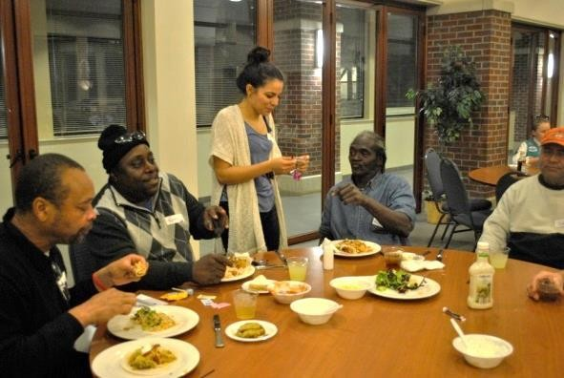
Everyone can become an expression of sanctuary. Ultimately, sanctuary offers one an experience of something sacred, something holy.”

There are several practical ways of expressing hospitality as part of the Room In The Inn winter shelter program;
  - Learn your guests’ names
  - Serve your guests at the table
  - Use “real” plates and silverware
  - Offer choices
  - Eat with your guests

HOSPITALITY IN THE SCRIPTURES
Genesis 18:1-8 Abraham’s visitors

Leviticus 19:34 “Love the alien as yourself”

1 Kings 17:10-24 The widow shows hospitality

Luke 10:38-42 Mary and Martha

Luke 14:12-14 “When you give a banquet, invite the poor”

Hebrews 13:2 “Some have entertained angels”
  - Consider any dietary special needs like low-sodium and low- sugar options; avoid serving hard or crusty foods because of dental issues
  - Take time to listen to your guests
  - Remember the small touches---magazines, newspapers, dominoes, playing cards, toiletries

One of the most important aspects of hospitality is seeing your guests as individuals and as more than homeless.

It is easy to focus on the struggles our guests face because they live on the streets. But every guest has unique experiences, talents, and interests. Try to learn more about the positive things about your guests.


Best Practices

Tips from Room In The Inn Congregational Coordinators

Create a volunteer apprentice position. Invite people to come for the first time and don’t ask them to do anything but simply get a feel for the program and figure out how they want to be involved.
Send out a pre-season email with all the dates for the season, what groups are covering what dates, what the expectations are, and what the plan for the season is.
Try to make all bed linens coordinate if possible. It is more inviting when the bed looks good. Use air mattresses. The guests say they are comfortable.

Have volunteers meet guests at the bus and help them carry their bags inside. Recruit volunteers to help with the administrative tasks of running the program. Wash guests’ clothes at a nearby laundromat.
Ask the guests what they really need in their toiletry bags.

Create a quiet area for guests who want to read or simply be quiet and relax. Let new volunteers shadow experienced volunteers.
Put a devotional item on each bed. Put a fresh pair of socks on each bed.
Watch Sunday night football or other sporting events with guests.

Let guests be involved in other activities going on in the building at the same time, like AA meetings, classes, etc.

Make specific requests when asking for donations to your clothing closet so you will not receive (as many) random or unnecessary items.
Serve popcorn or bake cookies after dinner. These are tasty snacks and also give people a feeling of home. Instead of toiletry bags, leave body wash, spray deodorant, and toothpaste on the sink in the bathrooms.
Have a conversation at dinner about what time breakfast will be served and when the bus will be leaving. That way there is no question in the morning.
Recruit volunteers by hosting Room In The Inn staff members or people who have been in the program and are now successful. This helps people know that their hospitality makes an impact.
Create a prayer station or wall. Both guests and volunteers can leave and/or take prayer requests.

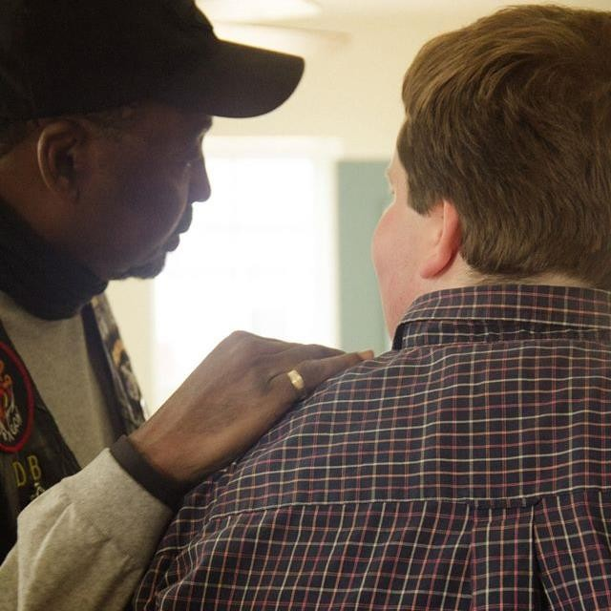
The Art of Being
Present

Room In The Inn guests face many struggles. Being homeless often means being lonely and isolated, having no one to talk with or to listen. This is especially true for someone with a mental illness. Spending some time just listening can really make a difference. Often the greatest gift you can give someone is your presence.

We have all known the long loneliness and we have learned that the only solution is love and that love comes with community.
Support People with Mental Illness
- Mental illnesses are medical conditions that require treatment
- Acts of violence are not typical for someone with a mental illness
- About 75% of Room In The Inn guests have some type of mental illness
- People with mental illness are not making things up or exaggerating things
- Refrain from judging someone’s behavior
- Try to move past your own fears or discomfort
- Be willing to listen to whatever someone has to say
- Express your interest and concern
- Don’t try to talk people out of their mental illness
- Accept people as they are
- Tell another volunteer or leader if you think there is a serious problem

Be a Good Listener
- Allow for plenty of time
- Give your full attention
- Don’t make the conversation about you
- Avoid trying to fix the situation
- Avoid giving advice
- Try not be nervous or uncomfortable
- Maintain appropriate eye contact
- Ask for clarification if you don’t understand something
- Ask open-ended questions
- Keep your emotions in check
- Refrain from being judgmental


The Holidays
Room In The Inn guests often say the holidays are very painful for them. Many of our guests are separated from family and do not have financial resources to buy gifts for or celebrate with loved ones. Feelings of loneliness and failure become more intense during the holiday season, leading to depression and further isolation. While the culture around them lavishly observes the holidays, people who are homeless are reminded of their own poverty.

There are some practical ways to provide comfort and support for your guests during the holidays.

- Be present with your guests. They may need you to listen or just sit with them.
- Invite them to take part in your congregation’s holiday services. They may need to be reminded of the spiritual meaning of holidays.
- Provide festive meals and home-made treats. It is comforting to have food that is reminiscent of home. One congregation serves a holiday meal to their Room In The Inn guests with fine china, lien
- Have greeting cards available and provide postage so guests can be in touch with loved ones.
- Give your guests presents or stockings to open. Remember, your guests have to travel light, so gifts should be portable. Some helpful items might include fast food gift cards, bus passes, good razors, wallets, small notebooks with pens, washcloths, scented body wash, jewelry and fragrances for women, candy, and individually-packaged snacks.
- Ask your children’s or youth choir to perform for your guests.
- Involve your guests in some aspect of holiday preparations: they can help put up decorations, decorate sugar cookies, or help put together food baskets for families.

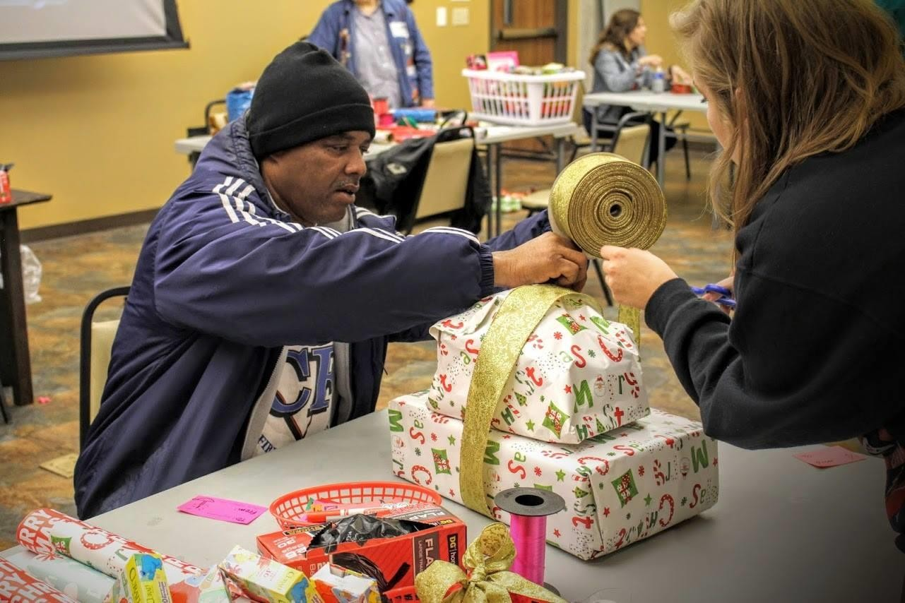

Practical Considerations

Insurance
- Standard liability policies cover all guests and visitors at a congregation. Room In The Inn guests are no different from other visitors to the building.
- If there is a concern about liability, congregations should consult with an insurance broker with experience covering non-profit agencies.

Cots/Mattresses
- Never use cloth-covered mattresses.
- Vinyl-covered mattresses or canvas cots are recommended.
- Cots are easy to store since they fold up. They can be tricky to assemble and may not support
larger guests.
- Some congregations use air mattresses. These are comfortable for the guest but can take a long time to inflate. Also, they can puncture easily.
- If a congregation cannot afford mattresses or cots, there may be another congregation which may be giving away its old ones or the RITI Board may be able to help. Please email us at ritilex@gmail.com

Transportation
- Many congregations have vans or buses. No additional insurance is necessary to transport Room In The Inn guests.
- There are congregations without vans that ask volunteers to use personal vehicles to transport guests. Again, no additional insurance is needed.
- We have a couple of congregations that rent vans every week for Room In The Inn.
- One congregation uses a taxi service to pick up guests, while another hires a limousine service.
- Another congregation borrows a van from a neighboring congregation.

Frequently Asked Questions

What night will we host Room In The Inn?

Each congregation chooses the night it will host Room In The Inn based on building usage and volunteer availability. The program operates seven days a week, and beds are needed every night.

How often do we have to host guests?

Some congregation’s welcome guests once per week while others once or twice each month. Each congregation plans its own schedule.

How many guests do we have to take?

Room In The Inn believes smaller groups provide more safety and the opportunity for conversation and relationship. Congregations typically take 10-12 guests, but each faith community decides how many guests it can comfortably accommodate in its facilities.

Should we be concerned about liability or insurance?

A congregation’s existing liability coverage will cover Room In The Inn. No congregations should have to purchase extra coverage since liability policies cover all visitors. RITI Board of Directors has purchased D&O Insurance that extends to our volunteers.

Do we have to have a shower?

A shower is not required to host Room In The Inn.

What do we use for beds?

Most congregations use folding cots or vinyl-covered mattresses. A few use air mattresses, but these can puncture with heavy usage. Make sure whatever bedding you use can be cleaned easily. Never use a cloth-covered mattress. Room In The Inn congregations usually purchase their own cots or mattresses.

How do we get bed linens?

Sheets and pillowcases are provided by the congregation and laundered by volunteers at the congregation. Often members will donate bed linens to the congregation’s Room In The Inn program.

What if there is an emergency?

If a situation is life-threatening or dangerous, congregations should call 911 immediately. For all other concerns or questions please call one of the individuals below. Please also follow up with an email to ritilex@gmail.com.
Steve Clark Dispatch Coordinator at 859-221-0009
John Waldron Dispatch Coordinator at 859-893-7821
Renee Gibson Chairman at 859-619-5502

What should we serve for meals?

Guests love simple, hearty, home-cooked food. For some guests, it could be their only meal of the day. Some guests may have dental issues, so it is a good idea to cut food like carrots and apples into slices and avoid crusty bread and harder foods. It is also good to have some food choices for people with high blood pressure or diabetes.

For breakfast, some congregations prepare a hot meal while others prefer a continental style breakfast with cereal, pastries, and fruit. Either kind of meal is appropriate.

Most congregations give each guest a sack lunch. Items in the lunch should not need refrigeration since guests have no access to a refrigerator.

